**PrimeOrbit's GCP Cost Optimization Platform: Integration Overview**

PrimeOrbit's platform is designed to help cloud consumers optimize their cloud spend by integrating seamlessly with various cloud providers through APIs. It operates in a non-invasive manner, meaning it does not require deep integration with the cloud provider's infrastructure, allowing customers to maintain full control over their cloud environments while benefiting from advanced cost optimization.

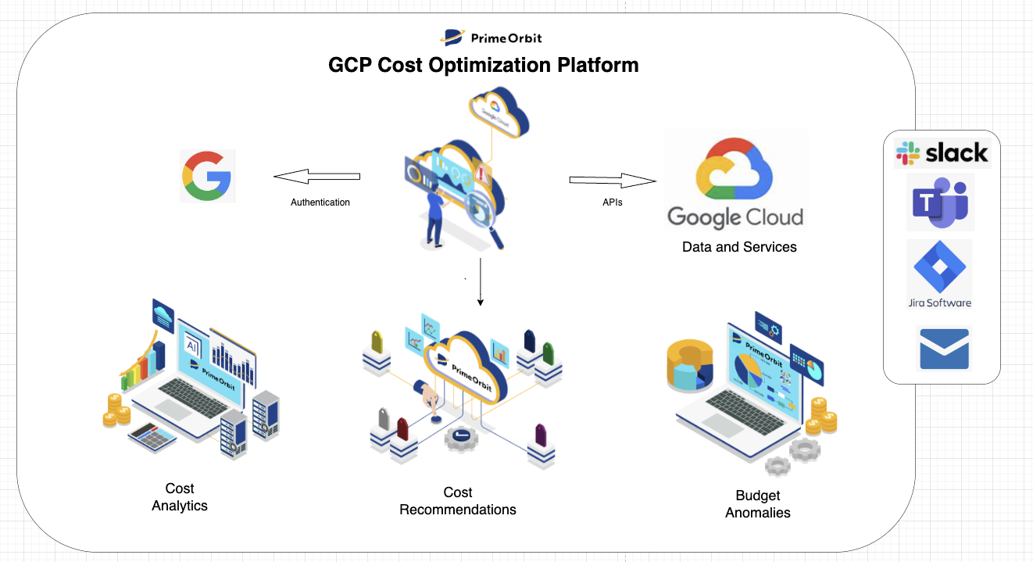

**How PrimeOrbit Works with Google Cloud Platform (GCP):**

1. **Authentication with GCP**The process begins with authenticating the customer’s Google Cloud account. This is facilitated through standard authentication protocols that ensure security and seamless access to the customer’s data without any intrusive steps.
2. **Accessing Data and Services via APIs**PrimeOrbit’s platform leverages Google Cloud’s APIs to securely pull the necessary data from the customer’s cloud environment. This includes usage data, resource allocations, and cost-related information, which are essential for effective cost optimization.
3. **Cost Analytics**Once the data is ingested, PrimeOrbit’s platform performs a thorough analysis of the cloud spending patterns. Using AI-driven insights, PrimeOrbit identifies opportunities for cost reduction across Google Cloud’s various services. The platform breaks down costs by specific Google Cloud services and resources, providing a clear overview of where savings can be made.
4. **Cost Recommendations**Based on the analysis, PrimeOrbit generates customized cost recommendations that help optimize the customer’s Google Cloud environment. These recommendations are focused on reducing unnecessary expenditures, enhancing efficiency, and improving the allocation of resources, all without impacting performance or scalability.
5. **Identifying Budget Anomalies**PrimeOrbit continuously monitors cloud spend to detect any anomalies that deviate from the expected budget. When such anomalies are found, alerts are triggered, and the platform provides actionable insights to resolve the issue, preventing any unplanned cloud cost escalations.

**Benefits for Google Cloud Customers:**

* **Seamless Integration**: No heavy integration required. PrimeOrbit interacts with Google Cloud via APIs to retrieve relevant data, ensuring a smooth and efficient process.
* **AI-Driven Insights**: Advanced cost analytics powered by AI deliver actionable recommendations to reduce waste and optimize cloud resources, specifically within the Google Cloud environment.
* **Improved Cloud Spend Management**: By identifying budget anomalies and offering actionable insights, PrimeOrbit enables customers to stay on top of their cloud costs, ensuring optimized spending aligned with business objectives.

PrimeOrbit’s solution for Google Cloud is designed to make cloud cost optimization easier, faster, and more effective, helping customers maximize the value of their cloud investments while minimizing unnecessary expenditures.

**GCP Onboarding Documentation for Customers:**

PrimeOrbit provides an easy-to-follow onboarding process for Google Cloud Platform (GCP) customers to get started with our cost optimization platform. The guide walks through the simple steps needed to connect your GCP account to PrimeOrbit, allowing you to begin optimizing your cloud spend with minimal effort.

Key steps include:

1. **Setting Up Authentication:** The guide explains how to securely authenticate your Google Cloud account with PrimeOrbit using standard methods, ensuring that only authorized data is accessed.
2. **Connecting via APIs:** You'll learn how to enable the necessary APIs to allow PrimeOrbit to securely retrieve cloud usage data from your Google Cloud account.
3. **Configuration for Optimization:** The guide provides instructions on setting up your PrimeOrbit account to begin analyzing your cloud spend. You'll be ready to start receiving actionable recommendations to reduce costs.
4. **Monitoring and Alerts:** After setup, PrimeOrbit continuously monitors your cloud spend and provides notifications for any budget anomalies, ensuring you’re always in control.

This onboarding guide ensures that you can quickly and easily integrate PrimeOrbit with your GCP environment, helping you unlock the full potential of cloud cost optimization without technical complexity.

For detailed instructions, refer to the full onboarding documentation here: [GCP Onboarding Guide](https://github.com/PrimeOrbit/neptune/blob/main/docs/onboarding/gcp/README.md).

******